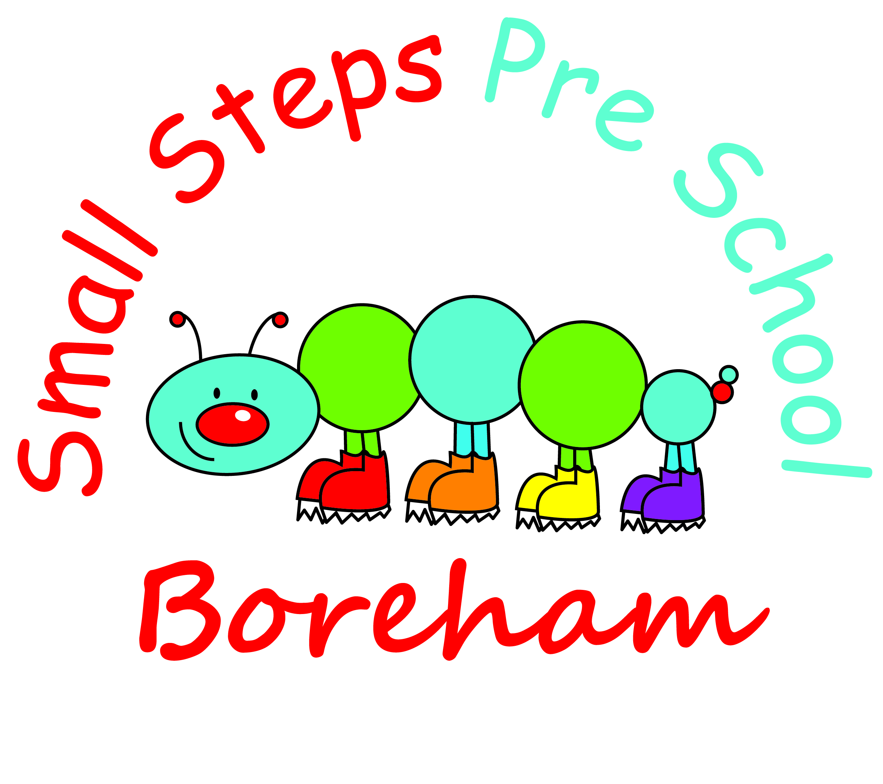
Company Reg. 7601172 Charity no. 1146534
Lord Perry Hall, Village Hall, Main Road, Boreham, CM3 3JD
Email: smallsteps1@hotmail.co.uk
Telephone: 07952 471616

Newsletter February/March 2020

Dear Parents,

Hope you all had a lovely break over half term and managed to get outside in between the showers?! Staff are looking forward to getting back to work and stuck into our new topics this week.

Topics for February and March: we are looking to stretch the topics over a two week period as there is so much to cover, 4 days just isn’t long enough!

24th February and 2nd March
Down on the Farm (including Pancake Day and World Book Day on 5th March) Linking to Little Red Hen, Rosie’s Walk, Farmer Duck and Chicken Lick’in.

9th and 16th March
Dinosaurs linked to Harry and the Bucketful of Dinosaurs.

23rd and 30th March
SPRING, covering the Easter Story.

Linked to Each Peach Pear Plum and other texts yet to be decided.

OPEN MORNING/EVENING
It was too difficult to find a mutually convenient time for you all and with previous Open Mornings so poorly attended we ask that you book in to see your child’s key worker during session time, either straight after drop off, before pick up or at a specific time during the session. Please book this directly with your child’s key worker or speak to staff.

Dates for your diary
Thursday 27th February Pyjama Drama 11am
Leanne will be looking at emotions: and in particular sharing and being kind. The children really enjoy these sessions. Please support us by bringing in a £3 suggested donation for this extra activity.

Thursday 5th March World Book Day
If your child would like to, they can come dressed as a character from a book. Bring the book with you if you’d like to. This is more about the book than dressing up. It isn’t about spending lots of money dressing up! Please only dress your child up if they are happy to do so. I’ve seen parents spending lots of money on costumes to get the perfect picture and witnessed the children hating every minute of it!! Staff will no doubt be dressing up (Lobster anyone??!) and we have lots of dressing up costumes so don’t feel pressured by it!

Saturday 28th March BINGO NIGHT Boreham SCHOOL 7pm £5 per person.
Please support us as we raise funds for new tablets for preschool, bring your Dabbers, drink and snacks lots of friends for an evening of BINGO!
We welcome donations towards the raffle, bottles of alcohol, toiletries, chocolates and gifts.

We only have 2 tablets in setting and they are now getting very slow to load entries onto Tapestry and we could do with at least one more so there are three in operation at any time.

Session price increase
After Easter our 3 hourly session rate will rise to £14. This is because our hall hire rate increased considerably in January and because of the 6.2% rise in the minimum wage which has a knock on affect to all our staff who equally deserve a pay increase. Funding for preschools is a contentious issue and many preschools and early years providers are closing every week because the gap between funding from Central Government has not increased in the same way. The session increase will only affect people who are not funded for their 2 year old but because the ratio of staff to children is higher for 2 year olds we feel the increase is justified. Also people who use over their 15 hours and want extra hours to will also have to pay the extra costs. Hopefully this higher fee will not deter new people from using our excellent service and judging from the research I’ve done we are still charging less than similar providers.

Reminder:
If your child is going to be absent for whatever reason, please remember to call or text and let us know on the first day of absence.

Committee Members

I hope you are all aware that Small Steps is run by a committee of volunteers! We would like to recruit some more members to replace those who have moved away recently. If you would like to join, please let me (Nicola Fung, Chair of the Committee) or a member of the team know. You can be involved as much or little as you like and you don’t have to attend all meetings. We aim to communicate by email as much as possible to limit the amount of meetings. All you need to do is to have a DBS/EY2 form completed and we can let you know how to do this.

Smaller Steps Baby and Toddler Group

Do help us to spread the word, feel free to share any posts on our open Facebook page and to let anyone know about us who might be interested in coming along.

SNACK DONATIONS
We provide snack for children on long days

Parish Council/Outdoor area update

I have had a letter from the Parish Council to let us know that following our disagreement to pay a charge to use the public Recreation Ground (which we have used non-exclusively for 10 years) they have now sought legal advice and have decided as a “goodwill gesture to issue a one-off grant to cover any rental fees for a one year period only” This is whilst a licence agreement is being worked on by their solicitor.
Our stance has not changed on this matter and we await the licence agreement. I will of course get legal advice on this as and when we receive it and let you know how we plan to respond.
I just wanted to say a big thank you to those of you who took the time, trouble and effort to write into the Parish Council, attend meetings and support us in this important matter. Outdoor play is a vital part of the children’s development and we will not give in to demands to pay for a service which does not cost the Parish Council anything extra to provide.

Preschool Uniform

If you would like to order preschool uniform, please visit:
https://myclothing.com/smallsteps-preschool/10589.school

Wearing a uniform really helps the children get ready for school, gives them a sense of identity and for those who get cross with paint or muddy clothes coming home when their child has had a full on day of FUN, it’s a godsend! The uniforms wash well, are cost effective and very reasonably priced. Mine are on their third use (when Miss will wear them!) and haven’t faded at all. It’s not compulsory but does gives a sense of belonging so is up to you.

As always, please get in touch if you have any queries or concerns and we will always do our best to resolve them. Have a lovely March!

Nicola Fung and the Small Steps Team

